Darlington Association on Disability

Centre for Independent Living

Breaking through Barriers

Impact Report 2013

Darlington Association on Disability is an organisation led by disabled people, which exists to promote independence and choice.

DAD supports disabled people and carers through the provision of services, support and information and by tackling issues affecting disabled people both locally and nationally.

Chair’s report 2012 - 2013

It has been another incredibly difficult year for disabled people and their carers. National welfare reforms and changes to social care locally have created uncertainty and anxiety leading to stress and, in some cases, worse. Meeting the increase in demand for services provided by Darlington Association on Disability that has come about by these changes has also been a great challenge to the organisation. I give the credit for Darlington Association on Disability’s accomplishments in these difficult times to all the dedicated staff and volunteers, who under the excellent managerial skills of Chief Executive Lauren Robinson and Assistant Chief Executive Jacki Hiles along with senior managers Tracy Roberts and Rosemary Berks, have once again done an outstanding job and I thank them all.

I have seen at first-hand the difference the various activities of Darlington Association on Disability have made to many disabled peoples’ lives’ some activities which I have been personally involved with and others that have been reported to me by people in the street, expressing their gratitude and asking me to pass this on to the management and staff.

I am immensely grateful to all our financial supporters and offer them our warmest thanks. However the constant struggle to secure core funding is ever present especially in these times of uncertainty and it is this funding which is vital if Darlington Association on Disability is to continue to take a leading role in changing negative attitudes that prevent disabled people participating fully as equal citizens.

I cannot overstate how appreciative I am to my fellow trustees for their support and continued hard work and their commitment to Darlington Association on Disability. I also offer them my sincere thanks for their hands on work, which goes above and beyond what is normally expected of a trustee.

Gordon Pybus

Chair, Darlington Association on Disability.

Advocacy
DAD supports disabled people and carers to say what they want, secure their rights and get services which they need. DAD also encourages self-advocacy.
Examples of our work in this area include:

- Supporting people to challenge discrimination
- Supporting Darlington’s People’s Parliament, a self-advocacy group for people with learning impairments. Members have delivered workshops, training and awareness-raising events covering Self Advocacy, Hate Crime and bullying
- Encouraging people at the Independent Living Hub to improve confidence-building skills as a step towards using their experience positively
- Working with disabled people and parents of disabled children to ensure their views are included in the assessment process
- Supporting people to challenge financial decisions made during the assessment process which impact on their ability to live independently
- Providing rights based information and support to enable disabled people and carers to self-advocate. A parent carer whose 15 year old disabled daughter was told she could not study health and social care at school as she would not manage the workload received support from the Equal Access project which resulted in her presenting a case which enabled her daughter to enrol on the course
- Supporting a disabled employee with written information about her rights after requests for reasonable adjustments regarding overtime were refused. As a result she is now working set hours as recommended by her GP, consultant and Occupational Health
- Launching the Advocacy Project, a free and independent advocacy service for individuals and carers, with a team of experienced advocates.
‘Advocacy is about enabling every person to have a voice of their own and ensuring that they are not excluded because they do not express their views in ways that people understand’
(A voice of their own, BILD, 2006)

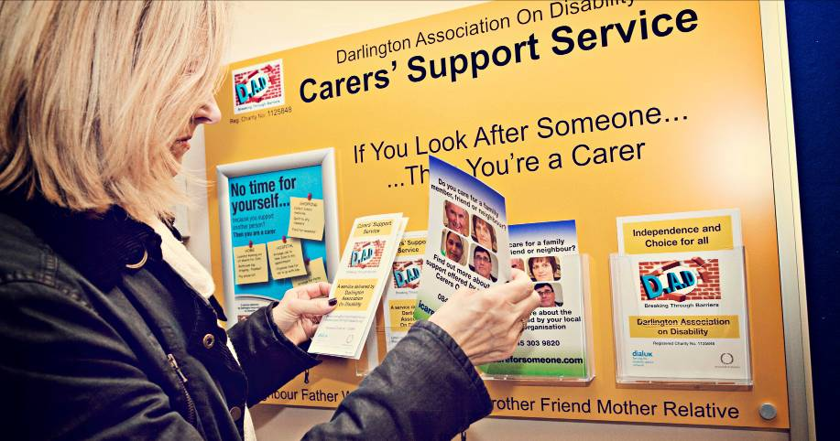

Access
DAD brings disabled people together to improve access by addressing barriers created by both the physical and attitudinal environment. It does this by promoting good practice around access issues, and by working with planners and providers to improve access to services. DAD also advises public bodies on how to carry out the duties imposed on them by the Equality Act.

Examples of our work in this area include:

- Delivering Induction Loop training to Darlington Borough Council and DAD staff to raise awareness of loop systems when booking meetings and venues for events

- Meeting with planning consultants and architects for a new town centre leisure development in Feethams, resulting in revision to the designs including ramps to ensure the area will be fully accessible

- Attending committee meetings to talk about the effects Darlington's new Wheeled Bin service could have on disabled people in the area. DAD ensured that the new system took into account people’s support needs

- Addressing issues around public transport, accessibility and the discriminative attitudes and practices of some drivers.

- Ensuring that planners took into account access legislation and the Equality Duty when making decisions about Town Centre planning applications

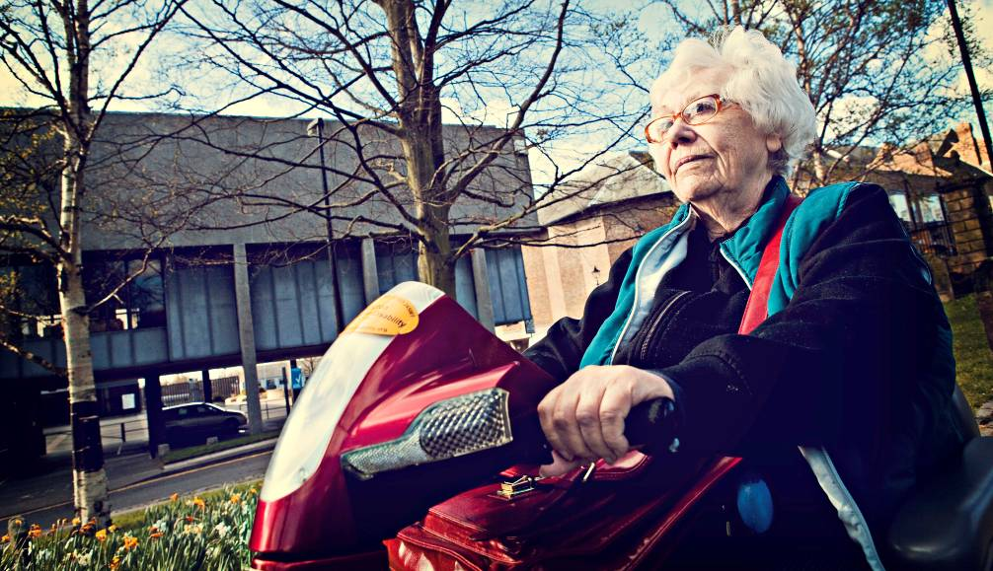

Campaigning
DAD is a non-political organisation; however it actively campaigns on issues which affect the lives of disabled people, families with disabled children and carers. DAD listens to its members and tries to influence decisions that are being made at a local and national level. Some examples of our work in this area are:

- Working to ensure that local Housing Policies support disabled people. The Equal Access project has dealt with an increasing amount of housing related enquiries from disabled people and carers about their rights when applying for housing, bidding for properties, under occupancy, changes to Housing Benefit and being assessed for adaptations. Enquiries are largely from within Darlington but some have been regional. The increase in enquiries led to a meeting with the Head of Housing at the Council to raise awareness of some of the common difficulties facing disabled people and the mitigation needed. The project is involved in the Tees Valley Choice Based Lettings focus group and regularly advises on disability issues linked to housing policy and procedures.

- Coordinating a DAD response to Darlington Borough Council’s draft Discretionary Housing Payment policy

- Joining national campaigns led by organisations such as the Alliance for Inclusive Education and Scope on a range of topics, including changes to the Benefits system and proposals to change Special Educational Needs (SEN) provision

- Gathering evidence and making the Council and other public bodies aware of the impact of the cuts on disabled people and carers. (welfare or financial needed before cuts?)

- Submitting consultation responses where the Government calls for evidence on issues such as welfare reforms

- Supporting young people to speak out about issues that affect them.

- Campaigning at a local and regional level for improvements in the way that disabled people who are the victims of hate crime are supported

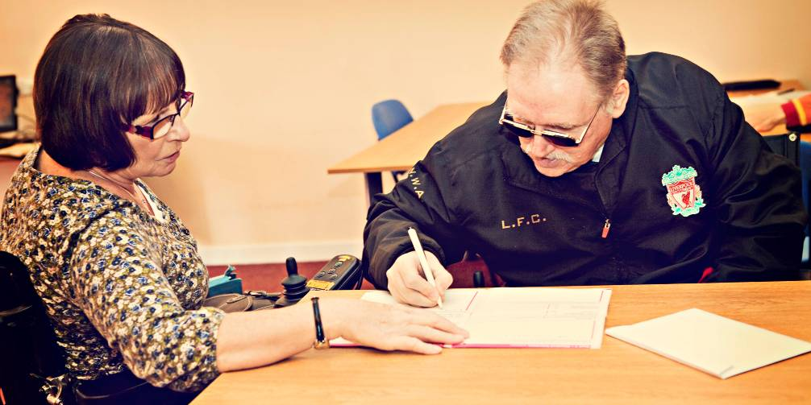
Peer Support
DAD offers opportunities for disabled people of all ages and carers to learn from one another, and to work together to tackle issues. This is called peer support.

Examples of our work include:

- Developing Stronger Voices... Strong Support – a project with an emphasis on peer support. The work has involved supporting people with personal budgets, delivering peer support workshops and sharing learning around the 7 steps model of support planning. The project supports people to become trained advisors and peer support planning partners, supporting people to make their own support plans. This increases knowledge and skills for disabled people and carers, further increasing capacity to deliver Peer Support
- Bringing people who use Direct Payments together for peer support in a regular monthly group meeting, enabling them to share experiences and influence service development.
- Facilitating a number of groups for carers, who are often isolated by their caring role, bringing people with similar experiences together, such as the Young Adult Carers group
- Recruiting young disabled people as volunteers on DAD’s playschemes, enabling them to develop skills as peer mentors and providing disabled children with positive role models.
- Enabling members of the Independent Living Hub to support each other to build confidence and find solutions to barriers which impact on their independent living.
- Running a Young Leaders group which enables young disabled people aged 14-25 to develop confidence and skills and gives young people a voice

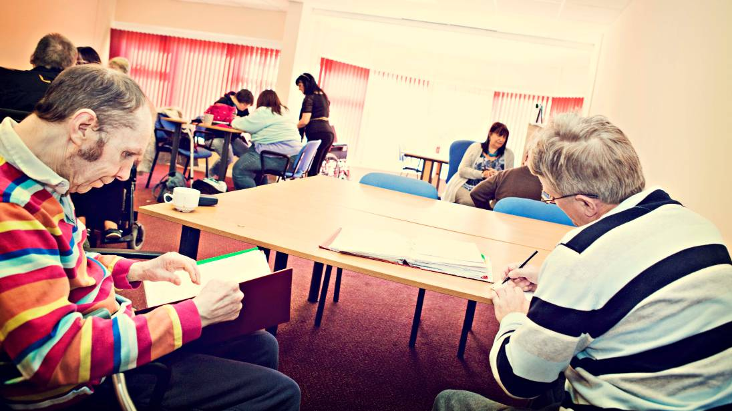
User Led
DAD is a user led organisation (ULO) which is run and controlled by people who use services, including disabled people, mental health service users, people with learning impairments, their families and carers. (Definition provided by the Social Care Institute for Excellence, 2009). This is fundamental to the way in which DAD works, as it means that people who use services direct and influence the organisation at all levels.

In order to meet this vision DAD-

- Has retained a longstanding commitment to being user-led, by enabling DAD to develop from a small charity led by disabled people, to a company limited by guarantee with a Board of Trustees, the majority of whom are disabled people, who direct the work of DAD

- Is committed to develop policies which actively support the recruitment and retention of disabled people as staff and volunteers

- Works with young people to produce leaders of the future; supporting them to get involved at all levels within DAD – as volunteers, staff and hopefully in the future as trustees.

- Facilitates a regular Stakeholder Forum where any member of DAD can raise issues of concern and consulting widely with our members

- Delivers training through projects such as Stronger Voices... Strong Support, recruiting people as trainers and volunteers who themselves have planned their own support and therefore have first-hand experience

- Involves disabled people in all recruitment and selection decisions.

“A ULO is an organisation based on clear values of independence, involvement and peer support. Unlike other voluntary sector organisations, service users control the organisation. ULOs are uniquely identified by their knowledge, which is based on direct, lived experience. These three criteria define a ULO” (Shaping Our Lives 2009)

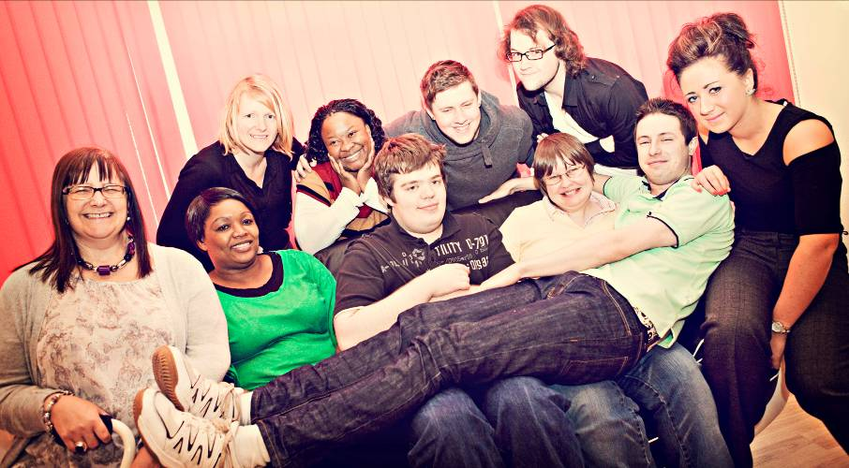

Co-production
DAD supports and encourages co-production, ensuring that disabled people and carers are involved fully including at the earliest possible opportunity when policies or services are being developed.

Co-production refers to a way of working where decision-makers and disabled people and / or carers work together to make a decision or develop a service which works for everyone. Co-production is built on the principle that those who are affected by a service are best placed to help design it.

Examples of co-production include:

- Producing and co-delivering Carer Awareness training to Health staff by a carer about the challenges she faces and the improvements in her life as a result of being supported, both through the Carers Support Service and through the Direct Payments Support Service. Feedback from Health staff shows that this co-delivery was a very effective way to deliver the message

- Working with the People’s Parliament to enable people with learning impairments to develop skills which they can use to co-produce local services, delivering training to health facilitators and getting involved in consultations.

- Supporting carers who sit on the Carers Strategy Steering Group, which determines how services for carers are developed and delivered in Darlington

- Championing the Co-production model with Darlington Borough Council as a way to effectively develop personalisation locally

- Ensuring that parents of disabled children have opportunities to influence the development of the local Special Educational Needs (SEN) Pathfinder programme

- Involving disabled people in the design of new buildings and in planning forums where they can influence decisions about access and service delivery

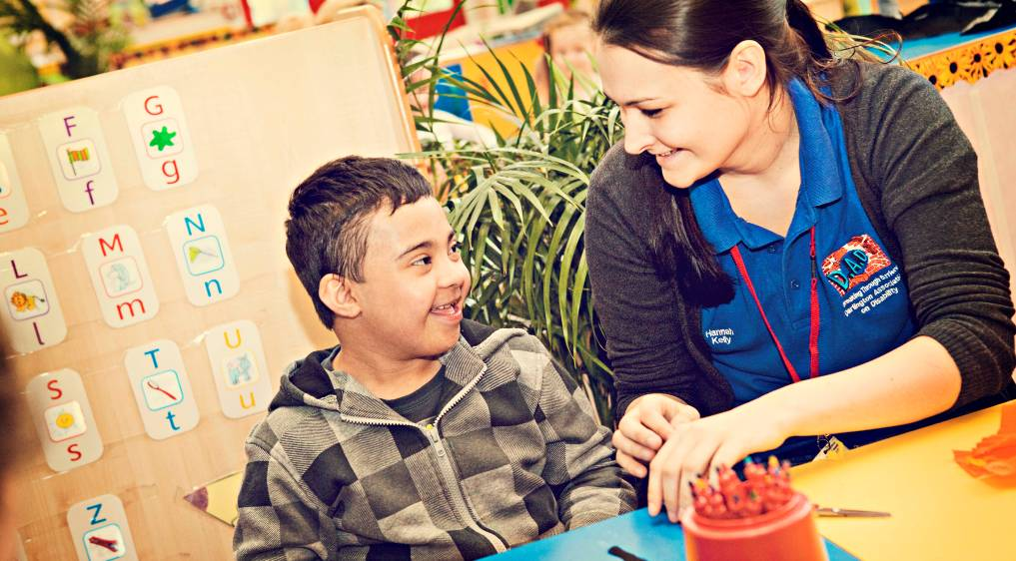
Training
DAD organises and offers training on a wide range of topics to practitioners and advisers, voluntary sector organisations, disabled people and carers. The purpose of training has been twofold – to increase the knowledge and skills of staff and volunteers within DAD in order to deliver the best possible service, and to improve the lives of disabled people and carers by providing them with a range of training.

Examples of training delivered to staff, volunteers and members during the year include:

- Mandatory training for staff which has included Safeguarding, Induction Loop Systems, Nonviolent Crisis Intervention, Disability Equality, Mental Health Awareness and the Equality Act 2010. DAD’s mandatory programme is designed to improve staff confidence, knowledge and understanding in key areas.

- Leadership and self-advocacy skills for members of the People's Parliament.

- Child Exploitation & Online Protection (CEOP) training

- Supporting people to develop and write their own support plans, delivered to volunteers by Stronger Voices... Strong Support

- Distance Learning Level 2 Qualifications in Equality and Diversity, Customer Services and Mental Health Awareness to staff, volunteers and members at the Independent Living Hub

- Health and Social Care NVQs for staff working at the Hub

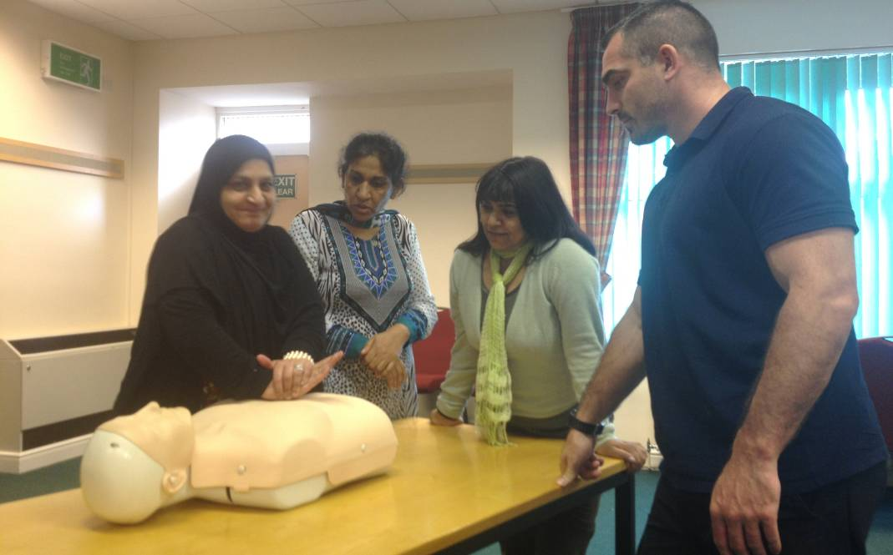
Training
Examples of training delivered by DAD to others outside the organisation include:

- A course on Hate Crime and Anti-Bullying, and training designed to raise awareness amongst young people about the new SEN ‘One Plan’ emphasising that they can be involved and have their voice heard when developing their plan. Both of these courses were led by members of the People’s Parliament

- Communicating and supporting children and young people who have experienced bullying or harassment, in partnership the Anti-Bullying Co-ordinator from the Borough Council. This was delivered to front line staff as part of the Safe Places to Be Initiative

- A programme for children and young people on Rights, Decision Making, Attitude to Self, Assertiveness, Team Work and Risk Taking.

- Carer Awareness to GPs and practitioners at Darlington Memorial and West Park hospitals and various surgeries around Darlington.

- Two bespoke Skills for Carers courses, which included sessions on confidence building, identifying and managing stress, managing your health effectively, techniques for relaxation and practical techniques for coping with caring.

- Induction Loops, for staff within the Borough Council

"I now have more confidences to talk to Doctors and consultants. I have realized that I am the professional in my caring role, not them."

"I am pleased that I came on the course, this has helped my confidences and I have found new friendships by participating."

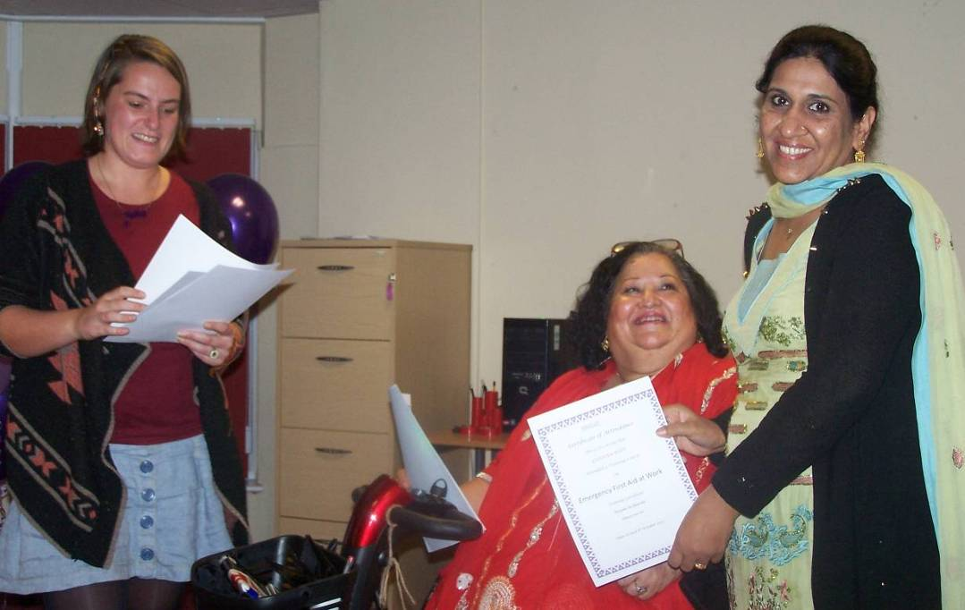

Personal Budgets and Direct Payments
DAD is committed to disabled people, parents and carers having more choice and control over the assessed services they receive. DAD offers information, advice and support to people to explore and use Personal Budgets, Direct Payments and Personal Health Budgets. Staff can also assist with the self-assessment process and support planning. Some examples of our work are:

- Beginning the transition to a new contract model after successfully tendering for the Direct Payments Support Service; the new model is based around offering a Menu of Support. Letters were sent to all service users and followed up with calls and visits to explain the changes.

- Supporting people impacted by changes to the severe disability premium proposal who could no longer afford their contribution to look at their disability related expenditure, and supporting them in financial reassessments. As a result, several people have had their contribution reduced

- Operating managed accounts that provide an opportunity for people to have a direct payment without the additional responsibilities of managing their finances

- Enabling disabled people and carers to explore imaginative and cost effective ways to receive assessed services. This has included supporting people to use direct payments flexibly. Examples include purchasing adapted computer equipment, costs for a PA to support a family on a short break, and transport and accommodation costs for a young person's PA to support them to attend the Special Olympics 2013

- Developing the Stronger Voices... Strong Support project to promote peer support, enabling people to become more involved in creating their own support plan

‘This place is a gem, there has never been an occasion where a member of staff hasn’t helped me with a query’.

'Without the support of a direct payment, DAD and my care manager my life would be very different. Thank you'.

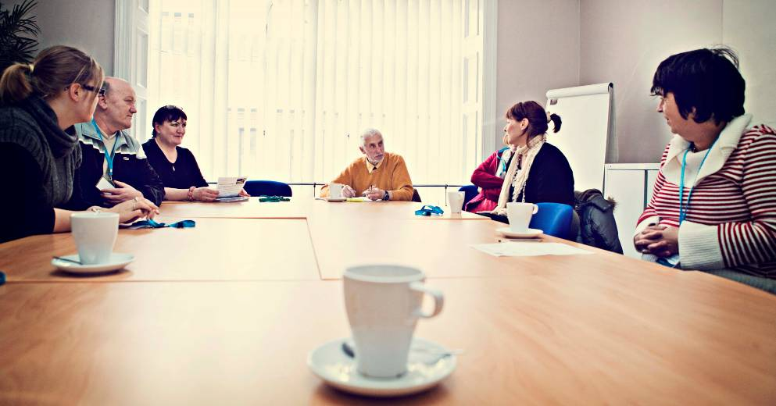
Choice, Control, Flexibility and Inclusion
As a Centre for Independent Living (CIL) DAD provides unique practical services which enable disabled people and carers gain and maintain control over their life. People using DAD have access to a wide range of support, including personal assistance, person centred support services, information and advice, co-production and training.

Some examples of our work in this area include:

- Supporting disabled people attending the Independent Living Hub to devise Personal Development Plans, including community involvement, education, training, leisure and employment
- Developing an outreach service so that people can receive support to access independent living, community and leisure services. The Independent Living Hub has also expanded to include support outside of the Hub and at evenings and weekends.
- Increasing the range of equipment available through Shopmobility, including short-term and long -term loans
- Delivering a range of holiday activities through DASH playschemes. This has included the development of close working relationships with a nursery and out of school provider, sharing premises and planning joint activities.
- Offering a wide menu of support to people using direct payments, including a robust recruitment service that helps people advertise for personal assistants
- Working together to add value to the service we provide. Examples include providing an information service alongside Shopmobility to enable first time customers to explore other sources of support.

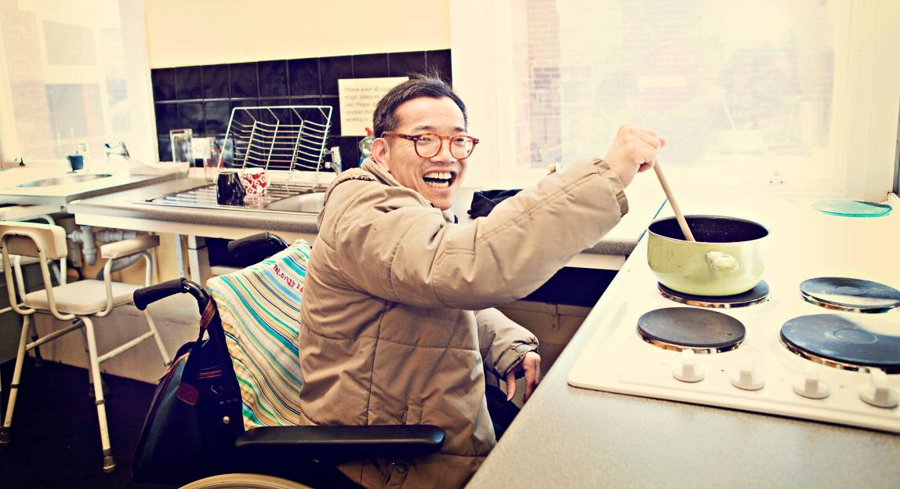
Information and Advice
DAD provides comprehensive, up to date information and advice on a wide range of topics. The organisation also supports disabled people and carers to make informed choices and increase independence through access to disability rights based information.

Some examples of our work in this area are:

- Developing a DAD Guide containing information on all of the services offered by DAD, and creating a new format for DAD’s newsletter combining information from all projects.

- Developing and circulating a practitioners resource for advisors on challenging social care and financial assessments. A ‘Sharing the Learning’ event was held for advisors, gving them skills to pass on to staff teams. The resource has a section for service users to empower them to take action themselves

- Enabling disabled people to get free high quality specialist legal advice about the judicial review process, increasing their understanding about their rights and how to challenge decisions

- Providing information and advice to people on a wide range of topics ranging from independent living, housing, adaptations and equipment, education and welfare rights. Researching social and sporting options for a wheelchair user led to him joining a local sports club and also resulted in a request for support with a funding application to enable young disabled people to participate in inclusive sport and develop Wheelchair basketball as a school game

- Working with other local services to deliver information and advice at community events throughout the Borough.

- Broadening support for carers by providing Information Boards in all GP surgeries and in several locations at Darlington Memorial hospital

- Providing information in a range of formats, including large print and audio versions of the Blue Badge guide, fact sheets and newsletters

- Promoting the Information Service through a local free magazine, which led to invitations to give (what?) across the Borough and has resulted in a significant increase in enquiries from disabled people and carers

- Securing grants for individuals totalling £2,297, for essential items including cookers, beds, carpets etc.

- Successfully challenging a number of decisions relating to what can be considered as disability related expenditure when financially assessing disabled people

Financial Information

The following figures are taken from the Report of the Trustees and Financial Statements for the year ended 31st March 2013 for Darlington Association on Disability.

The following graph shows the breakdown of Total Income of £993,336 split into:

Project income of £861,752;
Voluntary Income and grants of £12,264;
Fundraising Income of £118,845;
Bank Interest of £475.

Financial Information

The following graph shows a breakdown of the Total Expenditure £992,104 split into;

Project costs of £861,295;
Fundraising and Governance costs of £116,875;
Support Costs to Management of £11,656;
Depreciation of £2278

DAD would like to thank our funders and partners for their continued support:

Aiming High for Disabled Children, Children in Need, Darlington Borough Council, Darlington Comedy Festival, Darlington Primary Care Trust, Department for Education, Equality and Human Rights Commission, Northern Rock Foundation, The Big Lottery Fund.
DAD Services

Access Interest Group brings disabled people together to improve access for disabled people by addressing physical and attitudinal barriers.

Advocacy Project is a free and independent advocacy service for individuals and carers.

Carers’ Support Service provides free information and advice to anyone providing support to a family member, friend or neighbour because of age, illness or impairment.

Children and Young People’s Service provides inclusive and accessible play and leisure opportunities and support. It runs DASH inclusive play and leisure sessions during holidays for disabled and non-disabled children between the ages of 3 to 16 years.

Direct Payments Support Service provides a range of support about Direct Payments; one way to get more choice and control over social care support.

Information Service provides disability information and advice on options.

Shopmobility Service provides the loan of manual and electric wheelchairs and mobility scooters in Darlington Town Centre for anyone with a mobility impairment.

Volunteer Project recruits and supports volunteers to work in DAD and other organisations.

Independent Living Hub offers support to disabled people to increase self confidence; to identify and work towards personal goals. It also offers opportunities to meet new people, peer support and take part in a range of social activities.

Stronger Voices… Strong Support for disabled people who have used personal budgets to support others through advice and guidance, workshops, peer support and mentors.

Equal Access to Information and Advice Project supports disabled people and carers to make informed choices and increase independence through access to information about rights.

