Darlington Association on Disability
Impact Report March 2010

Welcome

Welcome to DAD’s Impact Report.

DAD was established in 1986 as a voluntary and charitable organisation led by disabled people. It exists to promote independence and choice and supports disabled people and carers through the provision of services, support and information and by tackling issues affecting disabled people locally and nationally. DAD promotes the social model of disability and is actively involved in promoting disability equality and awareness-raising.

The last eighteen months have seen a period of change during which we incorporated to become a Company Limited by Guarantee. We believe this strengthens our ability to deliver services that change people’s lives.

This Impact Report provides a flavour of some of our work as a User Led Organisation over the last eighteen months. To find out more about the full extent of our work please ask to see a copy of our full Trustees Report

User led and locally driven

DAD is driven by its commitment to being a User Led Organisation.

What is a User Led Organisation?

A User Led Organisation (ULO) is one which is run by and controlled by disabled people who use services. ULOs give people more choice and control over how their support needs are met. A report produced by the Prime Ministers Strategy Unit Improving the Life Chances of Disabled People (2005), and the Department of Health, recommends that each locality should have at least one ULO. Typically ULOs provide:

- Information and advice
- Peer support and advocacy
- Support to use a Direct Payment or Personal budget
- Support to recruit and employ personal assistants
- Assistance with self assessment
- Disability Equality Training
- Support for the implementation of the Equality Duty

As a ULO DAD also responds to the needs of local disabled people and carers, and involves them in designing, delivering and monitoring its services. DAD’s Memorandum and Articles are designed to ensure that disabled people maintain control of DAD. Our membership reflects the same principle.

DAD works to the Social Model of Disability, and works to remove barriers caused by Society for people with impairments.

DAD has over 3000 members

Independence, Choice and Control

We have-

- introduced Managed Accounts for people wishing to use a Direct Payment where they are unable to manage a bank account

- participated in the development of Personalisation in Darlington, by being involved in the design of systems, policies and procedures to be used by the Local Authority to give people more choice and control over the services they receive

- supported individuals to successfully challenge discriminatory practices under the Disability Discrimination Act
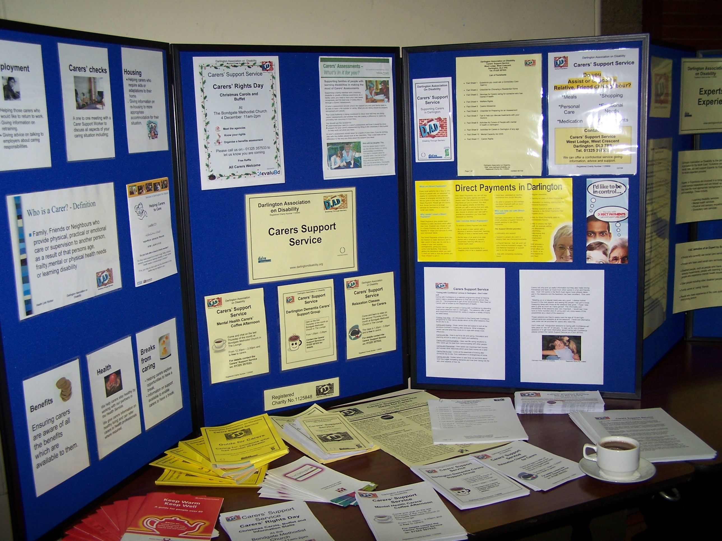

“DAD’s Dimensions Disability Initiative has changed my life, given me my confidence back. It has given me choices and the ability to move on”

“Because of the Carers Support Service I no longer feel alone or invisible”

Sarah is the parent of a young adult, Tom, with a complex learning impairment. Sarah supported Tom with his Direct Payment but due to some financial difficulties she could no longer continue. Sarah feared Tom would lose his Direct Payment but having a Managed Account for Tom’s Direct Payment enabled them both to still have choice, flexibility and control. Sarah is delighted with the new arrangement. as she feels Tom’s support is now more secure.

Over two thirds of our volunteers are disabled people

Promoting the Social Model of Disability

We have-

- tackled discrimination and victimisation by establishing DAD as a Third Party Reporting Centre for disabled people and carers wanting to report Hate Crimes and Incidents

- delivered training on Disability Equality, Disability Awareness and the Disability Discrimination Act to a wide range of public sector and independent organisations

- encouraged disabled people and carers to see themselves as ‘experts’ and to view their personal experiences as valuable

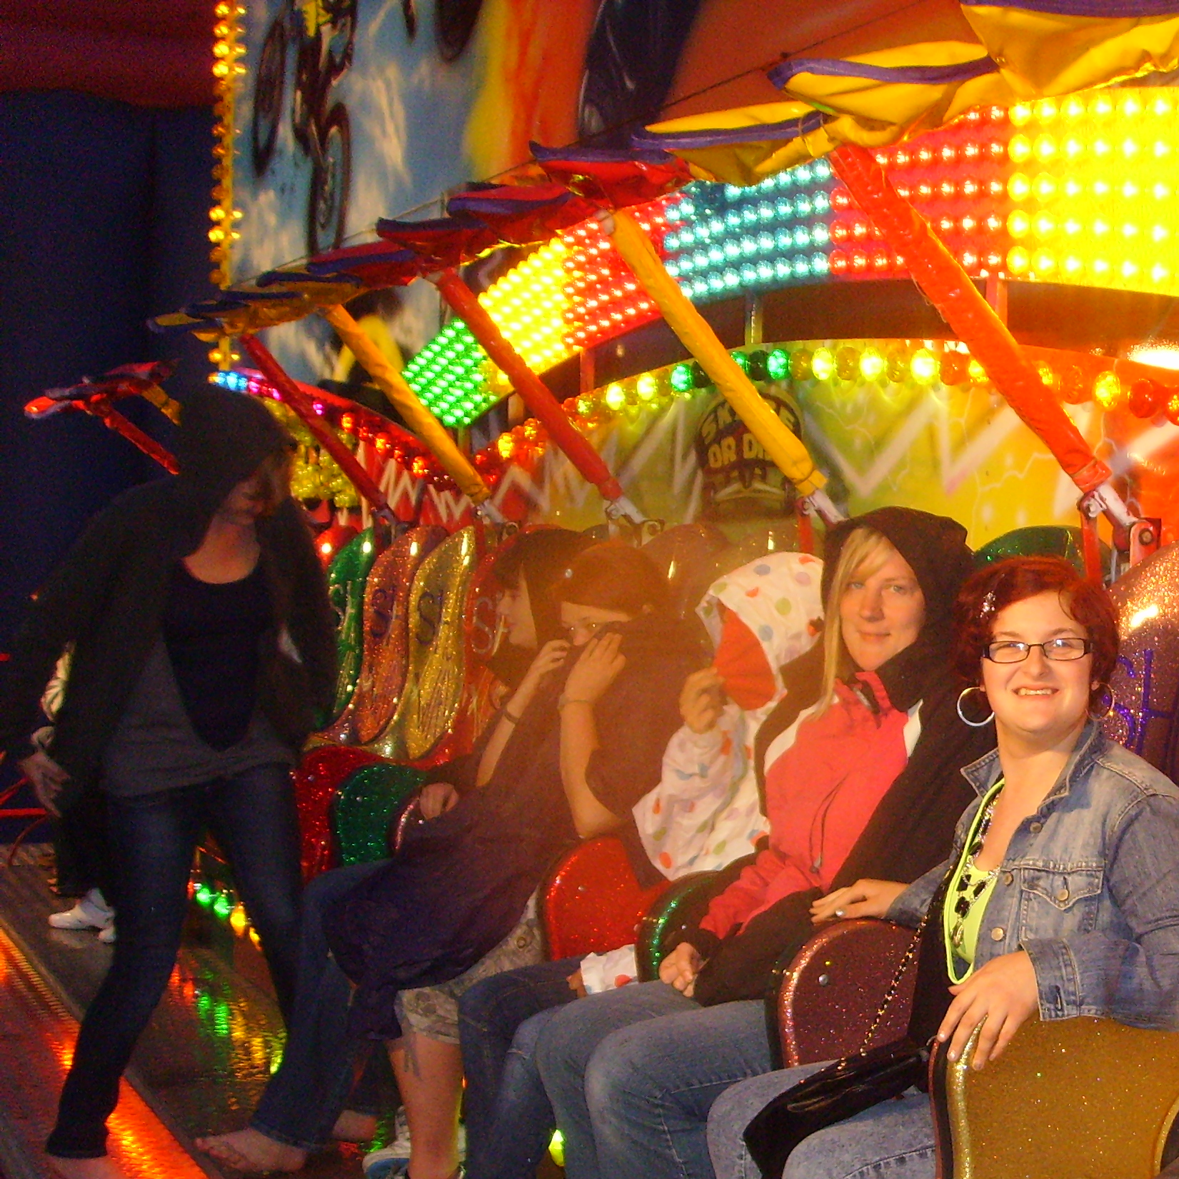

“I now feel my disability is not an end to my life but a new beginning”

Pete is one of over twenty disabled people working for DAD. Like many other disabled people he felt his impairment was a barrier to him ever achieving paid employment. After joining DAD as a volunteer and being encouraged to attend college Peter is now a full time and valued member of staff. “I am able to use the skills I have learnt through my own personal experience of disability, plus some of the more practical and theoretical skills I learnt from my college course to help me in my role as a PA.”

Disabled people make up 59% of DAD’s staff

Including everyone

We have-

- delivered inclusive play training to a wide range of staff in nurseries, Children’s Centres, private and voluntary sector play providers

- removed barriers to people's access to town centre services through the award winning ‘Wheelygood' website

- worked with staff in all GP surgeries across Darlington to identify and support carers

- enabled young people through the Young Leaders project to develop skills and knowledge, promoting a rights based, social model approach to the development of Disabled Leaders of the future.

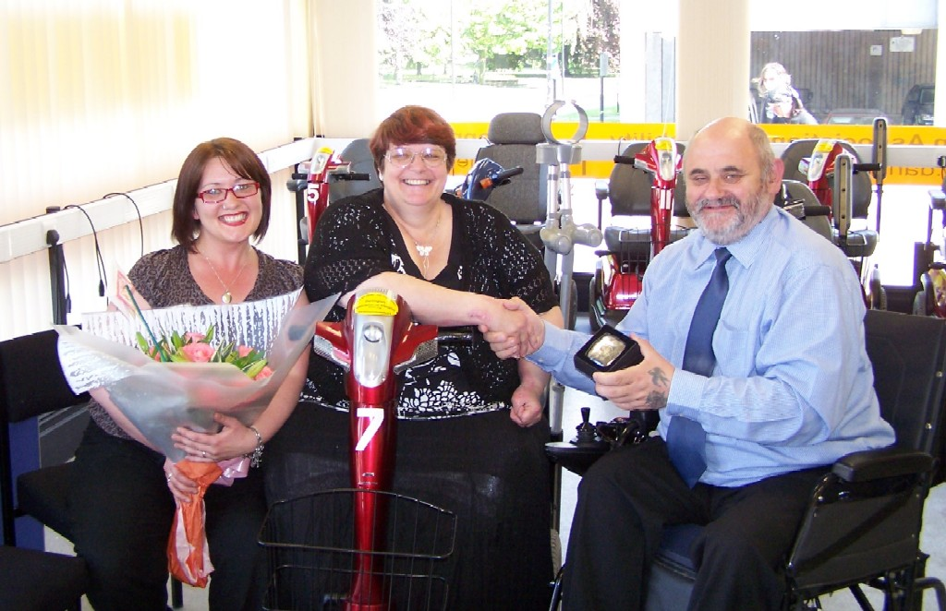
“Simply being able to do my own shopping using Shopmobility is great. Being able to go out alone is lovely. Getting my confidence back is amazing. Looking forward to the future is life changing!”

Teresa, a student, felt that the University she attended wasn’t meeting the specific access requirements relating to her hearing impairment. She approached DAD’s Equal Access to Information Service for support. Work by the service, together with specialist legal advice, resulted in an out of court settlement for £25,000 against the University for disability discrimination.

We respond to over 150 information enquiries each month

Working Together to achieve change

We have-

- developed a Personal Assistant (PA) Register of people who want to work with children, in partnership with children and young people using Direct Payments

- created a Young Leaders group as part of a national pilot funded by the Alliance for Inclusive Education (ALLFIE), to support DAD to be more inclusive of younger people

- facilitated a peer support group and User Involvement Forum to involve people in the development of Direct Payments

- recruited a team of Citizen Experts who will support the development of Personalisation
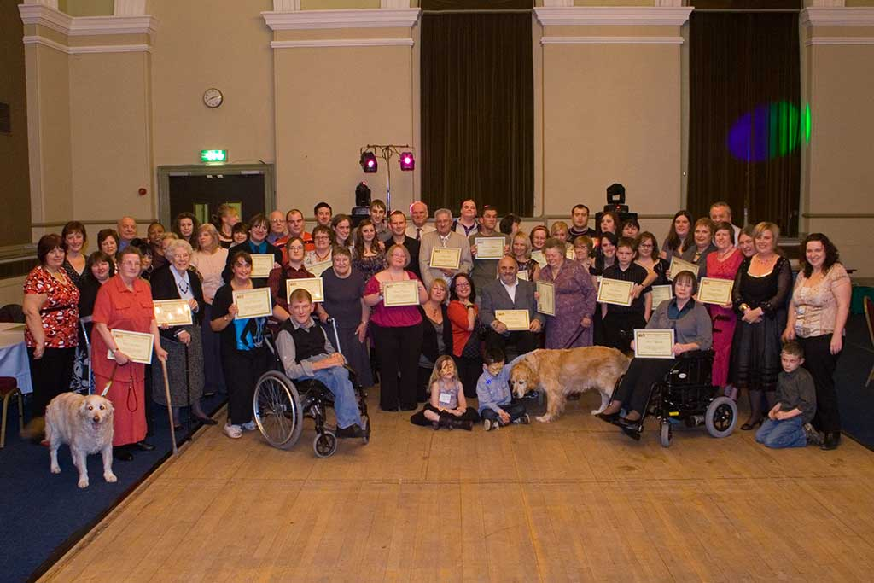

“This service has definitely improved my quality of life”

The Disability Impact Assessment sub-Group, whose membership reflects a broad range of impairments, has worked with Darlington Borough Council Officers to review and advise on a substantial number of plans, policies and strategies including the Corporate Plan, Play Builders project, Domiciliary Care tendering, Children and Young Person's Plan, Supporting People commissioning strategy, Transport Strategy and Disabled Children's Strategy.

Our Direct Payments team support over 350 people

Our wider impact

We have-

- Supported disabled people to directly employ over 500 people as Personal Assistants

- Enabled other User Led Organisations in the North east to develop in readiness for Personalisation, through Capacity Builders

- Influenced the development of a co-produced national common Resource Allocation System

- Employed Experts by Experience – all disabled people – to support Care Quality Commission inspections throughout the North of England

“The DASH scheme made a huge difference to my personal, mental and physical health. I was able to have time to myself and my son and we got to do activities together, without the worry and stress of having to consider my daughter’s complex needs”

Young Leaders have taken part in several Disability Impact Assessments, looking at proposed changes to local authority policies and services. This included a plan to move Connexions. The group carried out an in depth consultation, including site visits to the current and proposed venue. Using photographs they created a full scale plan of the interview room on the meeting room floor, and from it worked out that the proposed interview room was too small to be easily accessible for an accompanied wheelchair user. As a result revised plans for the new building have included a lift to enable use of an upstairs meeting room.

We reach over 1000 carers

DAD Services

DAD acts as a focal point for consultation with disabled people and carers and manages a range of services and projects to support its aims including:

- Access interest Group: Issue based groups which enable people to work together to promote access in it’s widest sense

- Carers Support Service: Support and information to carers and strategic policy development work on carers issues

- Care Quality Commission Expert by Experience Project: Recruitment, training and support of Experts by Experience to enhance the Inspection process

- Children and Young People’s Service: A range of services for children, young people and their families including play and leisure services and a Young Leaders project

- Dimensions: A disability initiative offering education, training, self-development skills, social and leisure opportunities

- Direct Payment Support Service: Support for disabled people to take control of their care needs by managing a payment from the local authority

- Disability Equality Training: Promotion of the social model of disability and the Disability Discrimination Act

- Equal Access to Information and Advice: Information and advice for disabled people about their rights, alongside a broader service handling a wide range of enquiries from the general public and other organisations

- Shopmobility: Free loan service of powered wheelchairs and scooters

- Volunteer Project: Recruitment and supporting volunteers across the organisation

