Darlington Association on Disability
Registered Charity 1125848


Breaking through Barriers

Impact Report March 2011
Darlington Association on Disability is an organisation led by disabled people, which exists to promote independence and choice.

DAD supports disabled people and carers through the provision of services, support and information and by tackling issues affecting disabled people both locally and nationally.

Chairman’s report 2010 - 2011

This year marks the beginning of many negative changes both nationally and locally for disabled people and carers. Proposals to reform the welfare benefits system are creating uncertainty and stress. Locally we are seeing Darlington Borough Council having to make massive savings that will lead to cut to services. Disabled people and carers will be affected both as citizens of Darlington and again as disabled people and carers, this in turn adds to more uncertainty and stress. One of the first Local Authority budget cuts was to the funding to run Darlington Association on Disability’s Shopmobility service and charging had to be introduced for the first time.

Whilst I recognise that Darlington Borough Council has difficult decisions to make about spending on services I also believe there should be no cuts to disabled peoples' services. However cuts there will be and I am committed to ensuring that disabled people in Darlington are fully involved in any decisions that affect them.

Unfortunately all the national and local upheaval over shadows other good results and the different projects within Darlington Association on Disability report many positive outcomes for disabled people and carers. Management, staff and volunteers have worked extremely hard to ensure Darlington Association on Disability fulfils its commitments to people. They have not only supported disabled people and carers but also each other, with many going that extra mile above and beyond as the demand on our services have grown. I am immensely grateful to them all and offer them my heartfelt thanks. I acknowledge the role played by the Chief Executive Lauren Robinson and Assistant Chief Executive Jacki Hiles and senior managers Tracy Roberts and Rosemary Berks in continuing to make Darlington Association on Disability a leading disability user led organisation and I thank them for their loyalty and dedication.

Chairman’s report 2010 – 2011

I can not overstate how appreciative I am to all our financial supporters, especially in these times of uncertainty, and offer them my sincere thanks.

I am indebted to my fellow trustees for their support to me and their commitment to Darlington Association on Disability. I also thank them for their many hours’ of hands on work as volunteers within the organisation.

Gordon Pybus
Chair, Darlington Association on Disability



User led and locally driven

DAD is driven by its commitment to being a User Led Organisation.

What is a User Led Organisation?

A User Led Organisation (ULO) is one which is run by and controlled by disabled people of all ages. ULOs give people more choice and control over how their support needs are met. A report produced by the Prime Ministers Strategy Unit Improving the Life Chances of Disabled People r(2005) recommends that each locality should have at least one ULO. Typically ULOs provide:

- Information and advice
- Peer support and advocacy
- Support to use a Direct Payment or Personal budget
- Support to recruit and employ personal assistants
- Assistance with self assessment
- Disability Equality Training
- Support for the implementation of the Equality Duty

As a ULO DAD also responds to the needs of local disabled people and carers, and involves them in designing, delivering and monitoring its services. DAD’s Memorandum and Articles are designed to ensure that disabled people maintain control of DAD. Our membership reflects the same principle.

DAD works to the Social Model of Disability, and works to remove barriers caused by Society for people with impairments.

DAD has over 3000 members
Independence, Choice and Control

We have –

- Started a pilot project - the Mentoring for Independence programme - to provide support to young people to increase their independence skills across four areas - travel training, cooking, budgeting and personal care

- Provided Disability Equality Training to members of the voluntary sector, including tailored disability equality training to staff supporting people with learning difficulties

- Completed and distributed the new DAD Information booklet which replaced individual project and service leaflets

Andrew used Shopmobility for the first time: “ I have been able to do all of my weekly shop and meet friends for lunch. I have spent time in the library catching up with my family via Facebook. I really believe that Shopmobility is vital for social inclusion as without it I could spend days without talking to anyone.”
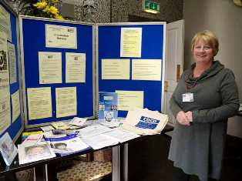

Jane is 82 years old and lives alone. She has family but they all work and have busy lives. When the Direct Payments service visited it was clear that she was not getting the support she needed to get out and socialise. Jane was quite isolated. The lead worker reassured her that getting more support would not lead to an increased contribution and supported Jane to ask for some more support which was assessed. Jane is now enjoying the extra support.

Over two thirds of our volunteers are disabled people
Promoting the Social Model of Disability

We have –

- Had a successful out of court settlement on a long-running Disability Discrimination Act case

- Become a third party reporting centre for people with learning disabilities to report Hate Crime

- Supported DAD’s work by maintaining a bank of regular volunteers to work across the organisation, and by recruiting and placing sessional volunteers for DASH play schemes.

‘I am a disabled person and a volunteer with DAD. I found a volunteer placement with the support from the Volunteer Support Worker in a charity shop, which has a lovely atmosphere. The staff and volunteers are friendly and supportive and there is a lot for me to do. This is a wonderful thing.’

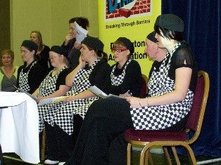

Isobel is a member of Dimensions. “I was asked by my Social Worker if I would like to attend Dimensions. At the time I had never heard of it. At first it took me a lot to get myself motivated because my confidence was zero. This past year has been overwhelming. I have enrolled in courses at the Sixth Form College and Teesside University. If not for Dimensions and the incredible staff I would never have had the courage to do any of the things I have done.
“As well as feeling better in myself, my family have all noticed a very big change. It would be fair to say Dimensions has saved me and my sanity!”
Disabled people make up 59% of DAD’s staff
Including everyone

We have-
- Run a series of user involvement forums focused on the service user guidance for personal budgets and seven in-control steps.

- Launched a new peer support group aimed at removing the barriers for older people to be involved in peer support and user involvement.

- Held DAD’s first Youth Forum, led by young people

- Restructured the service and DASH to improve the service for children, young people and families

Kate, a 3 year old, was signposted to the Children and Young People’s Inclusive Support Service, by the Direct Payment Support service. ‘I have realised what Kate aged three, can and has achieved over the playscheme, and how well other people can support her. I know now to back off, and not prevent her from participating.’

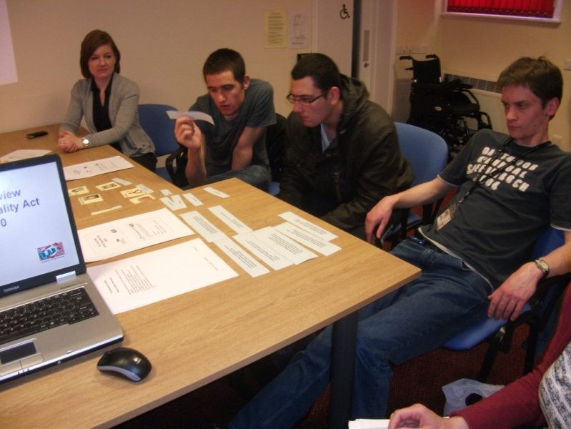

Kate’s parents were very apprehensive about leaving her with someone who was not her immediate family, but trust soon developed and her parents began to develop trust with her Personal Assistant during the three hours a week support sessions supporting Kate in their home while they went shopping etc. Attending the DASH Playscheme gave her parents the opportunity to attend appointments and spend some quality time together. This also gave Kate the opportunity to develop social skills and experience new activities.

We respond to over 150 information enquiries each month
Working Together to achieve change

We have-

- Continued to develop a Personal Assistant Register and Bank of support workers

- Launched a Young Adults Carers project in partnership with the YMCA young carers project, to involve and support young adult carers (16 – 25)

- Held a series of discussion sessions within DAD before preparing and delivering a report for disabled people and carers on Darlington Borough Council’s Fairer Contribution Policy.

“The session was both valuable and informative which I feel has provided me with a solid foundation to take into my future practice, thank you ” after personalisation training delivered to students at New College Durham.

The Capacity Builders project worked with small User Led groups across Tees Valley. Training was delivered on support planning so that groups could support disabled people and carers in their area.

Stockton Helps All advocacy service benefitted from the sessions and thought the training would enable them to support others. A parent carer, supporting their child through transition into adult services, found the experience very helpful. “It was really appreciated that Jenny told her story and made the experience real.”

Over 400 people use Direct Payments Support Service

Our wider impact

We have-

- Provided training for staff and members of Darlington Borough Council on the Disability Equality Scheme and the importance of impact assessments

- Planned a TV and radio campaign in partnership with carers’ support services across Tees Valley

- Supported an Expert by Experience to attend two national briefing days to train other experts on how to conduct thematic inspections.

- Delivered training on Support Planning and Personalisation and Carers to staff and volunteers from organisations across the Tees Valley area

“I really enjoyed doing this,(support planning) it was hard work but it something I needed to do. It is the first time that I have really had to think about what is important in my life and how I can have control.”

Mrs Jones had not been able to work for over a year due to illness. Her employer would not make any adjustments for her return to work and after 30 years’ service she was dismissed. Mrs Jones put in an unfair dismissal complaint which was rejected by her employer so she went to an employment tribunal. She had no legal representation for the tribunal. At the pre-case meeting, the judge told Mrs Jones she should get legal advice or representation after the employers’ solicitor had offered her £1,500 settlement. The Access Interest Group gave Mrs Jones advice on how the case would be handled and spoke to a solicitor from the firm of solicitors D.A.D. works with and asked them to contact Mrs Jones and offer more advice if needed. The case was settled a few days later out of court; Mrs Jones accepted £30,000 pounds plus a reference

We reach over 1000 carers
Financial Activities

Financial Summary 2010/11

The following figures are taken from the Report of the Trustees and Financial Statements for the year ended 31st March 2011 for Darlington Association on Disability.

The following graph shows a breakdown of the total Income £968,699 split into:
Bank Interest of £192, Project Income of £845,322. Voluntary Income Grants of £73,987, Financial Assistance Funding of £16391 and Fundraising Income of £23,807.

Financial Activities

The following graph shows a breakdown of the total Expenditure £930,987 split into:
Fundraising and Governance Costs £99,334; Project Costs £798,113; Support Costs Management £31,325 and Depreciation £2,215.

DAD would like to thank our funders for their continued support:

The Big Lottery, Children in Need, Darlington Borough Council, Durham County Council, Darlington Primary Care Trust, Department for Education, The Home Office, Aiming High for Disabled Children, Scope, Parent Forum, Coleridge Centre, Capacity Builders, Sunderland University, Equality and Human Rights Commission, Tees Valley YMCA, Changemakers, Future Jobs Fund, and The Alliance for Inclusive Education – ALLFIE.

DAD Services

DAD acts as a focal point for consultation with disabled people and carers and manages a range of services and projects to support its aims including:

- Access interest Group: Issue based groups which enable people to work together to promote access in it’s widest sense

- Carers Support Service: Support and information to carers and strategic policy development work on carers issues

- Citizen Experts and Expert by Experience Projects: Recruitment and training people with direct experience to be involved in personalisation locally and CQC inspections nationally

- Children and Young People’s Service: A range of services for children, young people and their families including play and leisure services and a Young Leaders project

- Dimensions: A disability initiative offering education, training, self-development skills, social and leisure opportunities

- Direct Payment Support Service: Support for disabled people to take control of their care needs by managing a payment from the local authority, including managed accounts.

- Disability Equality Training: Promotion of the social model of disability and the Equality Act

- Equal Access to Information and Advice: Information and advice for disabled people about their rights, alongside a broader service handling a wide range of enquiries from the general public and other organisations

- Shopmobility: A loan service of powered wheelchairs and scooters

- Volunteer Project: Recruitment and supporting volunteers across the organisation

